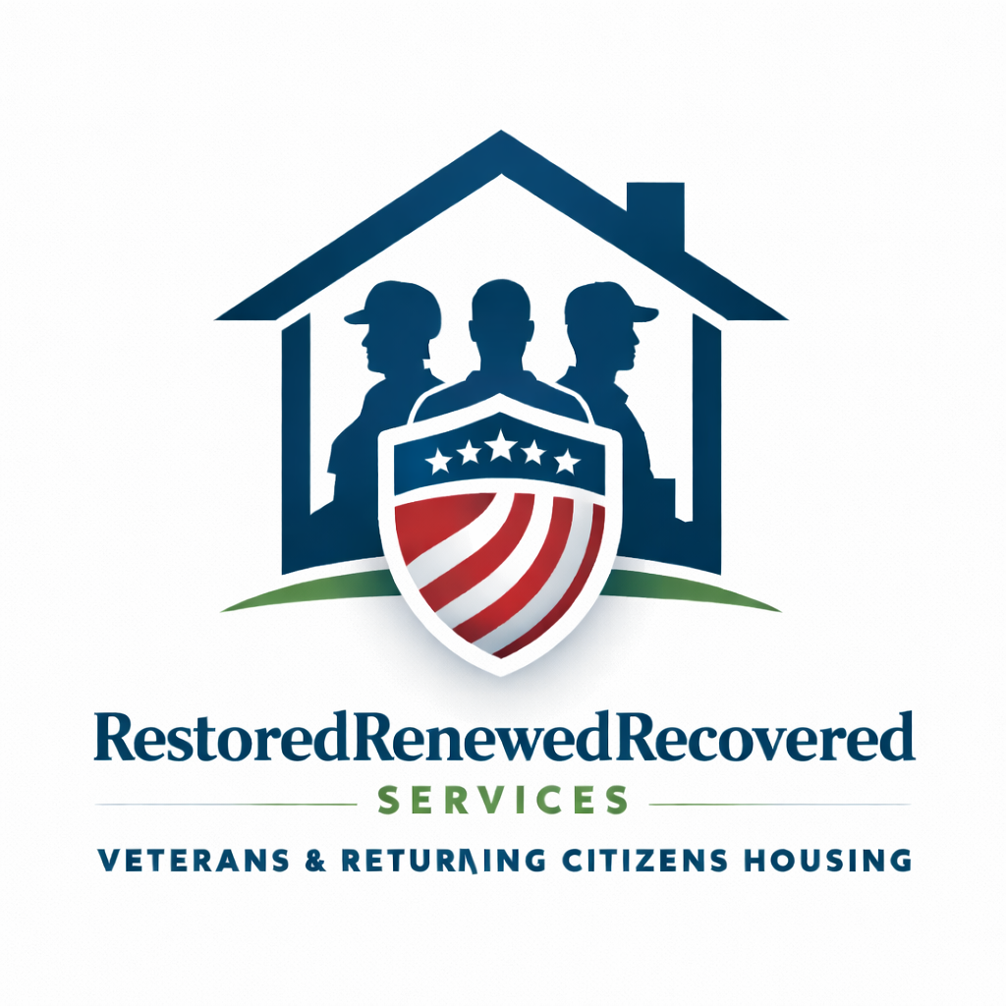

RestoredRenewedRecovered Services
Independent Living Facility
Operations Manual & Resident Handbook
Effective Date: February 21, 2026

1. Mission, Vision & Core Values
Mission: To provide structured independent living for income-verified Veterans and returning citizens committed to stability, accountability, and forward progress.
Vision: To create safe, disciplined, and opportunity-driven housing environments that reduce recidivism, increase employment stability, and promote responsible reintegration.
Core Values: Accountability, Integrity, Respect, Personal Responsibility, Community Safety.

2. Legal & Operational Structure
This Independent Living Facility (ILF) provides shared housing only. No medical, therapeutic, detoxification, counseling, or clinical services are provided. Residents are independent adults responsible for their own healthcare and personal affairs.
Residency may be subject to applicable provisions of the Virginia Residential Landlord and Tenant Act (VRLTA). All enforcement actions will comply with applicable Virginia law.

3. Residency Eligibility Criteria
- Verified lawful income (employment, VA benefits, SSI/SSDI, pension, or approved source).
- Income must equal at least 1.5x monthly program fee.
- Background screening required.
- May be on probation (must disclose and sign limited communication release).
- No registered sex offenders.
- No recent or repeat violent felony history posing direct safety risk.

4. Intake & Screening Process
Applicants must complete a written application, submit income verification, consent to background screening, and participate in an interview. Approval is not guaranteed.

5. Financial Policies
- Monthly program fee due on agreed date.
- Late payments may result in written notice and termination procedures.
- Security deposit required prior to move-in.
- Program Rule Violation Fees may apply for documented infractions.

6. Curfew Policy
Sunday–Thursday: 10:00 PM
Friday–Saturday: 12:00 AM
Exceptions granted for verified employment.
First violation: Written warning.
Second violation within 30 days: Program Rule Violation Fee equal to 25% of monthly fee.

7. CCTV & Surveillance Policy
CCTV is installed in shared common areas only (kitchen, living room, dining room, hallways, exterior front/back). No surveillance in private spaces. Cameras are used for safety, property protection, and policy verification.

8. Prohibited Conduct – Immediate Termination
- Violence or threats of violence
- Illegal drug use or distribution
- Illegal weapons possession
- Theft or property damage
- Harassment or intimidation
- Criminal activity on premises
- Unauthorized occupants

9. Absence & Abandonment Policy
Three (3) consecutive days of absence without communication will be considered voluntary abandonment. Belongings held for 7 days before disposal or storage fees apply.

10. Emergency & Law Enforcement Protocol
In cases of violence, medical emergency, criminal activity, or immediate safety risk, emergency services will be contacted.

11. Property Maintenance & Cleanliness
Residents are responsible for maintaining cleanliness of shared spaces. Routine inspections may be conducted with reasonable notice.

12. Termination & Due Process
Management reserves the right to terminate residency with 30 days written notice for non-compliance. Immediate termination may occur for prohibited conduct. Where required, termination procedures will comply with Virginia law.

Resident Agreement Acknowledgment
I acknowledge receipt of the RestoredRenewedRecovered Services Operations Manual & Resident Handbook. I agree to comply with all policies outlined herein.
Resident Name: ___________________________
Signature: ________________________________
Date: _________________________________
Management Representative: ___________________________
Signature: ________________________________
Date: _________________________________

